
EPHEMERAL COMMUNICATIONS
Submitting in partial fulfilment of the requirements
for the Award of the Degree of

BACHELOR OF COMPUTER APPLICATIONS

By
Abhijit Sudheer
23BCNB03

Under the Mentorship of
Dr. Stephen A



KRISTU JAYANTI COLLEGE
K. NARAYANPURA, KOTHANUR POST,
BANGALORE - 560077 2025– 2026



CERTIFICATE FROM MENTOR

This is to certify that this internship work titled Ephemeral Communications is based on an original project study conducted by Abhijit Sudheer (23BCNB03) of VI semester BCA with Analytics B under my mentorship.

This project work has not formed the basis for the award of any degree/ diploma by Bangalore North University or any other university.

Place: Bangalore
Date:
Name of the Mentor Dr. Stephen A



CERTIFICATE FROM DEPARTMENT
This is to certify that this project work titled Ephemeral Communications is based on an original project study conducted by Abhijit Sudheer (23BCNB03) of VI semester BCA with Analytics[B] under mentorship of Dr. Stephen A.

This project work is based on the original and has not formed the basis for the award of any degree/diploma by Bangalore North University or any other University.

Head of the Department [Prof. Sevuga Pandian A]

Table of Contents

1. Project Synopsis 2
1.1 Purpose: 2
1.2 Goals: 2
1.3 Intended Audience: 3
2. Project Objectives 4
2.1 Real-Time Session Management 4
2.2 Instantaneous Message Delivery 4
2.3 Privacy and Statelessness Assurance 4
3. Project Outline 5
3.1 Real-Time Communication Module 5
3.2 Interactive Visualization & UI Module 5
3.3 Session Lifecycle & Access Control Module 5
4. Technologies Used 6
4.1 Programming Language 6
4.2 Development Platform 6
4.3 Database & Storage 7
4.4 Other Tools & Frameworks 8
5. Screenshots 9
6. Project Features 11
6.1 Real-Time Messaging 14
6. 2 Ephemeral Room Management 15
6. 3 Participant Presence Indicators 16
7. User Guide 17
8. Conclusion 18
9. References 19

Project Synopsis

Ephemeral Comms is a real-time ephemeral communication platform developed to enable temporary, privacy-focused group messaging for small teams and individuals. Built on a modern web stack with a React/Vite frontend deployed on Vercel and a Node.js/Socket.IO backend hosted on Render, the application provides a stateless, zero-persistence environment for transient communication, allowing users to dynamically create or dissolve chat rooms from a centralized interface.

1.1 Purpose
The primary purpose of this project is to provide a lightweight yet secure tool for users who require temporary, disposable communication channels without the overhead of conventional messaging platforms. In a privacy-conscious digital landscape, the ability to communicate in real time without leaving a persistent data trail is essential for sensitive discussions, ephemeral collaboration, and short-lived project coordination. This project automates session lifecycle management and presents it through a clean, responsive chat interface.

1.2 Goals
Real-time Communication: To enable live, bidirectional messaging using WebSocket connections via Socket.IO, ensuring instantaneous message delivery across all active participants in a session.
Resource Management (CRUD): To implement a full lifecycle for chat rooms, allowing users to create, join, and dissolve communication sessions dynamically without requiring system restarts or administrative intervention.
Zero Persistence by Design: To guarantee that no message history, user data, or session metadata is retained after a room is dissolved, providing a privacy-first architecture with no long-term data footprint.

1.3 Intended Audience
The project is designed for:
Small Teams & Project Groups: Who need a quick, disposable communication channel for short-duration collaboration without committing to a full-featured platform.
Privacy-Conscious Users: Who require temporary discussions where message persistence poses a confidentiality concern and data minimization is a priority.
Web Developers & Students: Who are exploring real-time web technologies such as WebSockets, event-driven architecture, and modern CI/CD deployment pipelines as part of academic or independent development work.

- Project Objectives

The primary goal of Ephemeral Comms is to establish a robust, real-time communication framework that prioritizes transience, privacy, and simplicity. The project aims to achieve the following specific technical and analytical objectives:

2.1 High-Availability Monitoring
To develop an automated room lifecycle system that continuously manages the creation, activity, and dissolution of ephemeral chat sessions, determining their operational state (Active, Idle, or Closed) in real time. This objective focuses on ensuring that session events — including user joins, departures, and room expiry — are captured and reflected immediately on the communication dashboard.

2.2 Latency Trend Analysis
To implement a low-latency, event-driven messaging pipeline using WebSocket connections that transmits messages between participants with minimal round-trip delay. By maintaining persistent socket connections through Socket.IO, the system aims to eliminate polling overhead and provide users with a seamless, near-instantaneous communication experience throughout the session lifecycle.

2.3 Statistical Performance Benchmarking
To enforce and validate a zero-persistence architecture by ensuring that no message content, user identity, or session metadata is written to any long-term storage medium. This objective enables trust-driven communication by providing quantitative and architectural guarantees that all data is irrecoverably discarded upon session termination, supporting compliance with privacy-first design principles.

Project Outline

Ephemeral Comms is structured as a modular web application that separates real-time communication, server-side session logic, and frontend user interaction. The system is organized into the following key components:

3.1 Data Acquisition & Monitoring Module
This backend module, powered by Node.js and Socket.IO, is responsible for the core messaging logic. It manages WebSocket connections for each active chat room, handling event emission and reception for message delivery, user join/leave notifications, and session state broadcasting. It also enforces the ephemeral contract by ensuring no message payload is persisted beyond the active socket lifecycle.

3.2 Interactive Visualization & UI Module
The frontend module provides the user-facing chat interface built with React and Vite, styled for a clean and responsive experience. It allows users to create or join rooms, send and receive messages in real time, and view live participant presence — all without requiring a page refresh, driven by reactive state updates tied directly to Socket.IO events.

3.3 Data Persistence & Reporting Module
This module manages the creation, monitoring, and termination of ephemeral chat sessions. It governs room identity, participant capacity, and session expiry logic, ensuring that rooms are cleanly dissolved when all participants disconnect or a defined timeout is reached. Access control mechanisms such as password-protected rooms are handled here, preventing unauthorized entry into active sessions.

  - Flow Diagram:
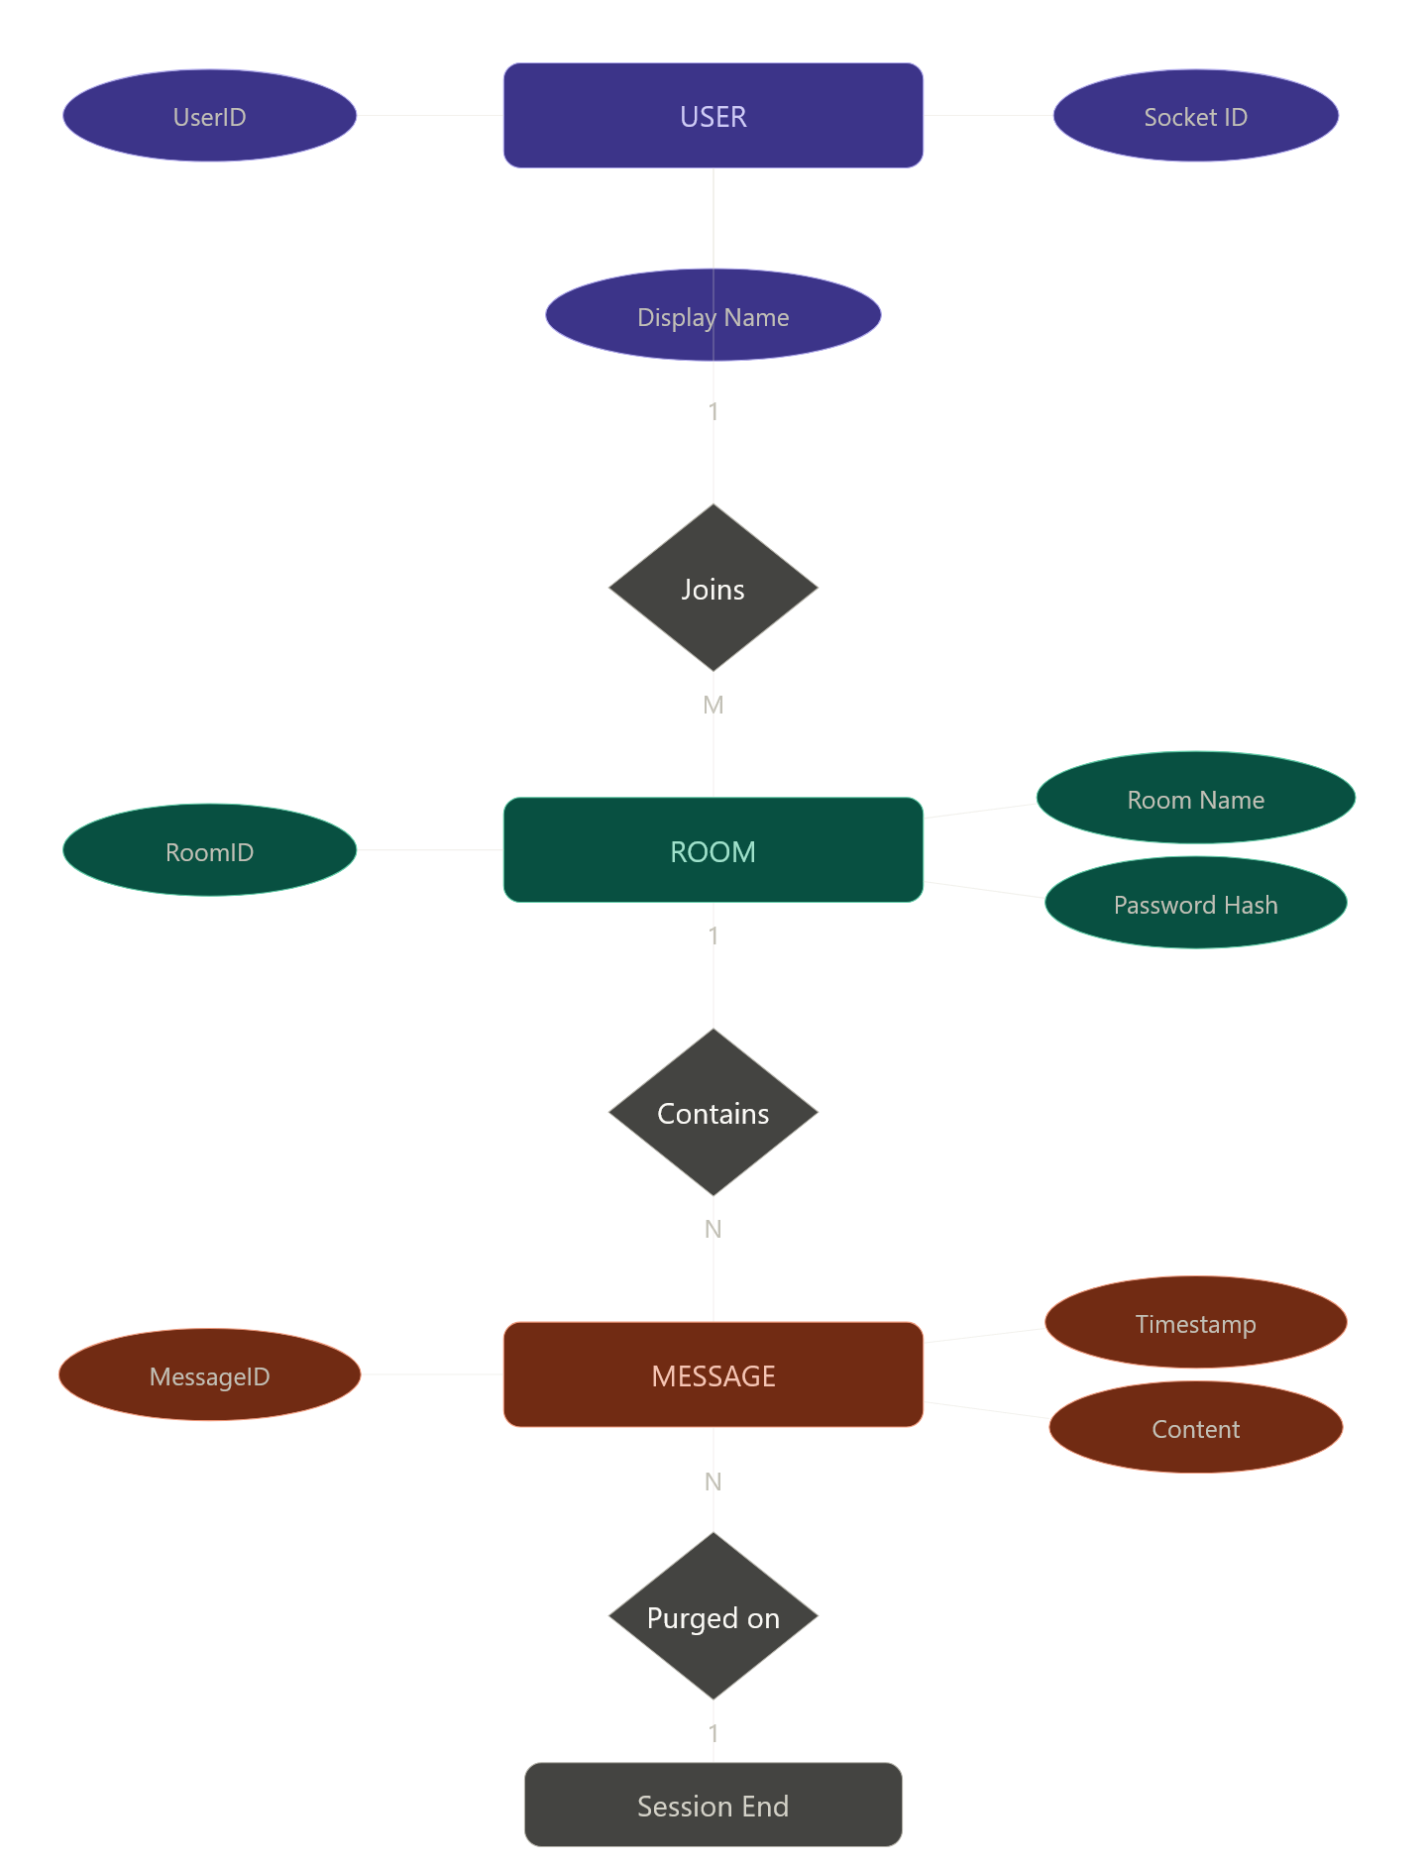

4.Technologies Used

Ephemeral Comms is built using a modern full-stack architecture that prioritizes real-time communication, stateless session management, and seamless deployment across distributed cloud platforms. The following technologies, tools, and frameworks were utilized in its development:

4.1 Programming Language
JavaScript (Node.js): The entire backend logic is implemented in JavaScript running on Node.js, leveraging its event-driven, non-blocking I/O model — ideal for managing concurrent WebSocket connections and real-time message broadcasting.
JavaScript (React): Used on the frontend to build a reactive, component-based user interface that updates instantly in response to incoming socket events without requiring page reloads.

4.2 Development Platform
Vite: A next-generation frontend build tool used to scaffold and bundle the React application, providing fast hot module replacement during development and optimized production builds.
Socket.IO: The core real-time communication framework used to establish persistent, bidirectional WebSocket connections between the server and all active clients within a room.
Nix Flake/Podman: Utilized for containerization to ensure consistent development and deployment environments across different machines.
4.3 Database & Storage
In-Memory Session State: For ephemeral performance, the application utilizes server-side in-memory data structures to track active rooms, connected users, and live message streams — with no writes to any persistent database.
Zero-Persistence Design: By architectural intent, no database or file-based storage system is used. All session data, messages, and user presence information are discarded permanently upon room dissolution.
4.4 Other Tools & Frameworks
Express.js: A minimal Node.js web framework used to structure the backend server, handle HTTP routing, and integrate Socket.IO for WebSocket event management.
Tailwind CSS: The primary utility-first CSS framework used to design the responsive chat interface, room creation screens, and participant presence indicators.

5.Screenshots
Login Page(Making a new room)
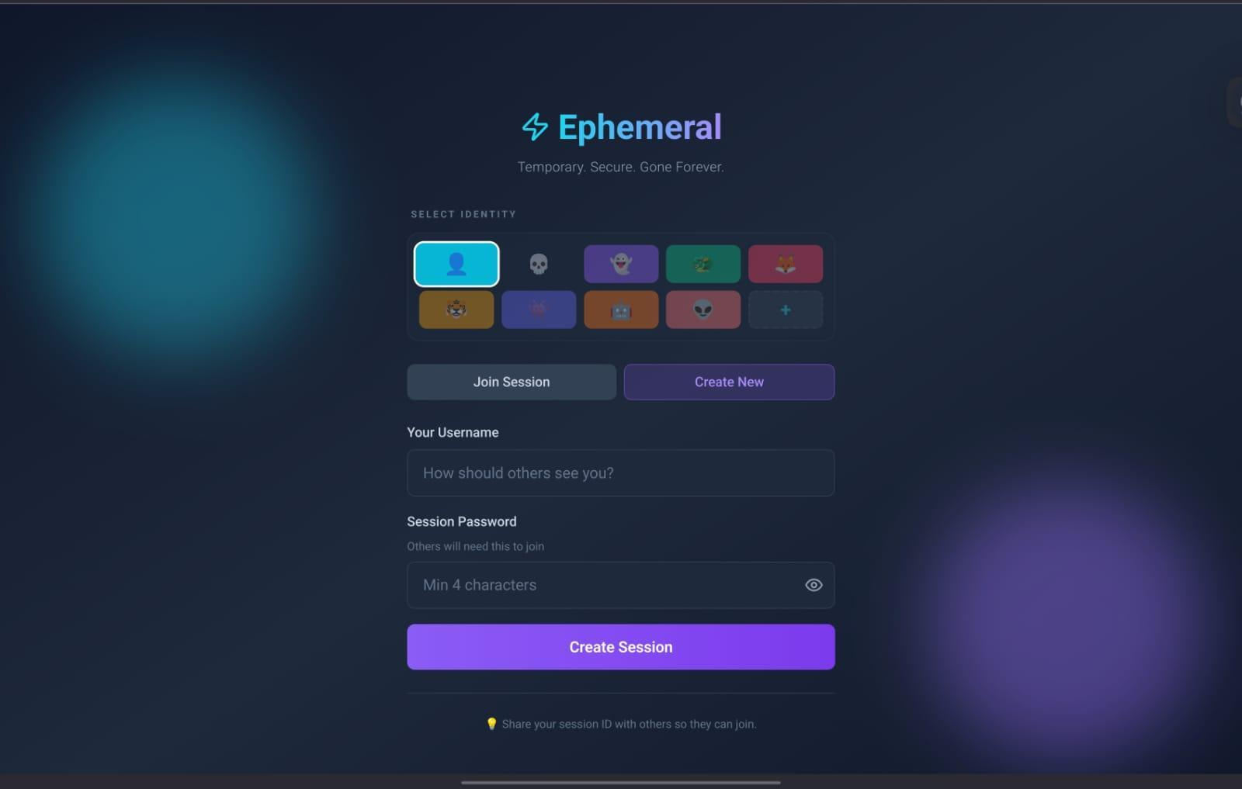
Login Page(Entering an existing room)
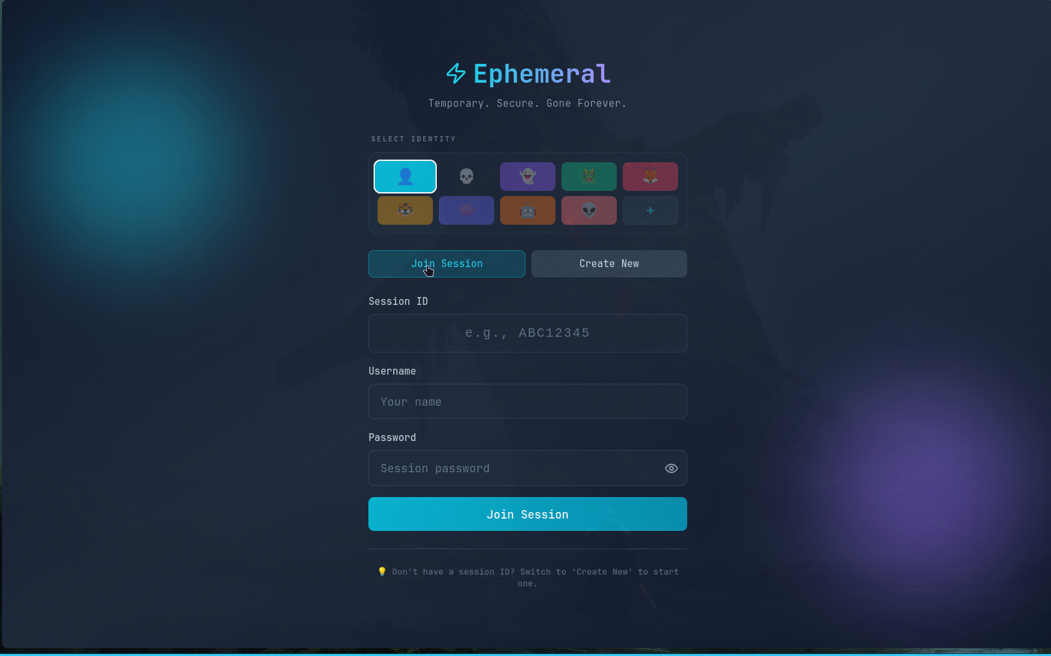
Page of the Chat Room
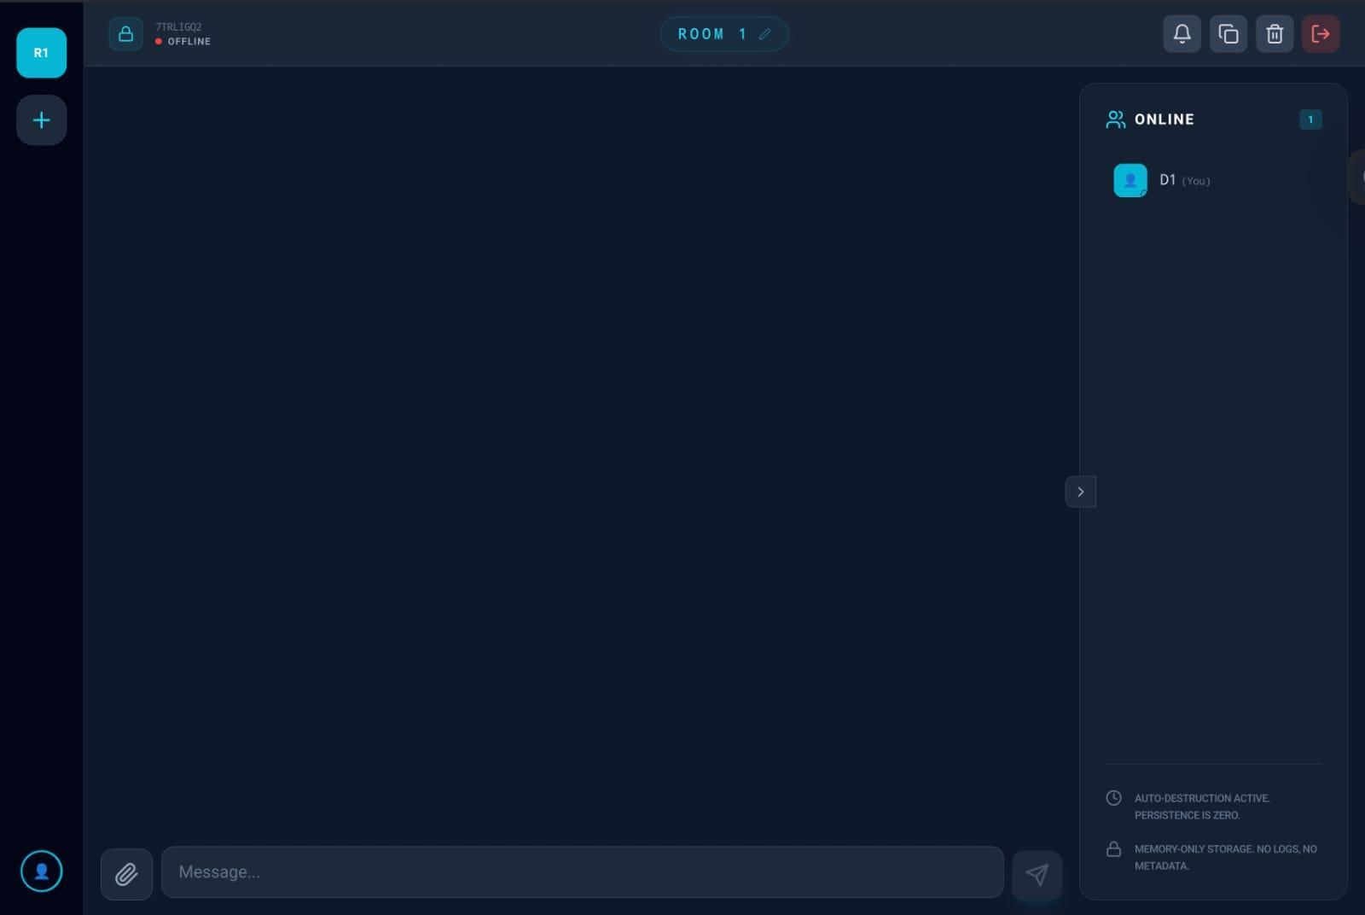
Code of Flake.nix(Docker substitution)
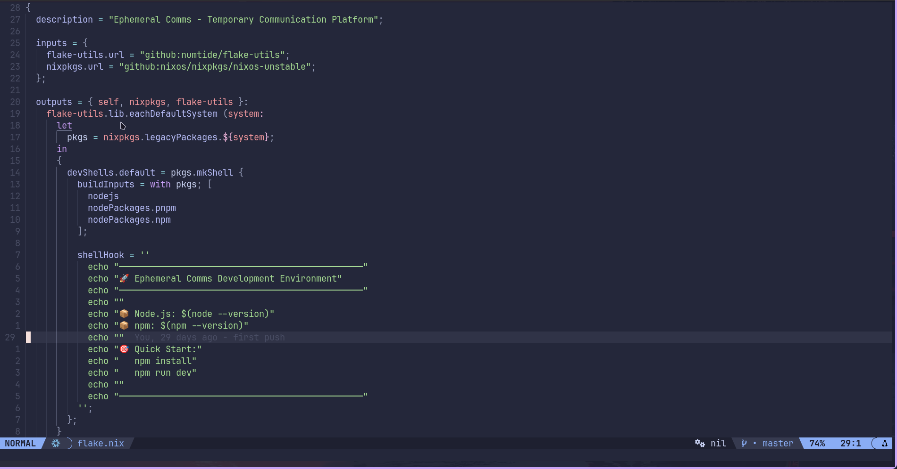

FrontEnd React Execution
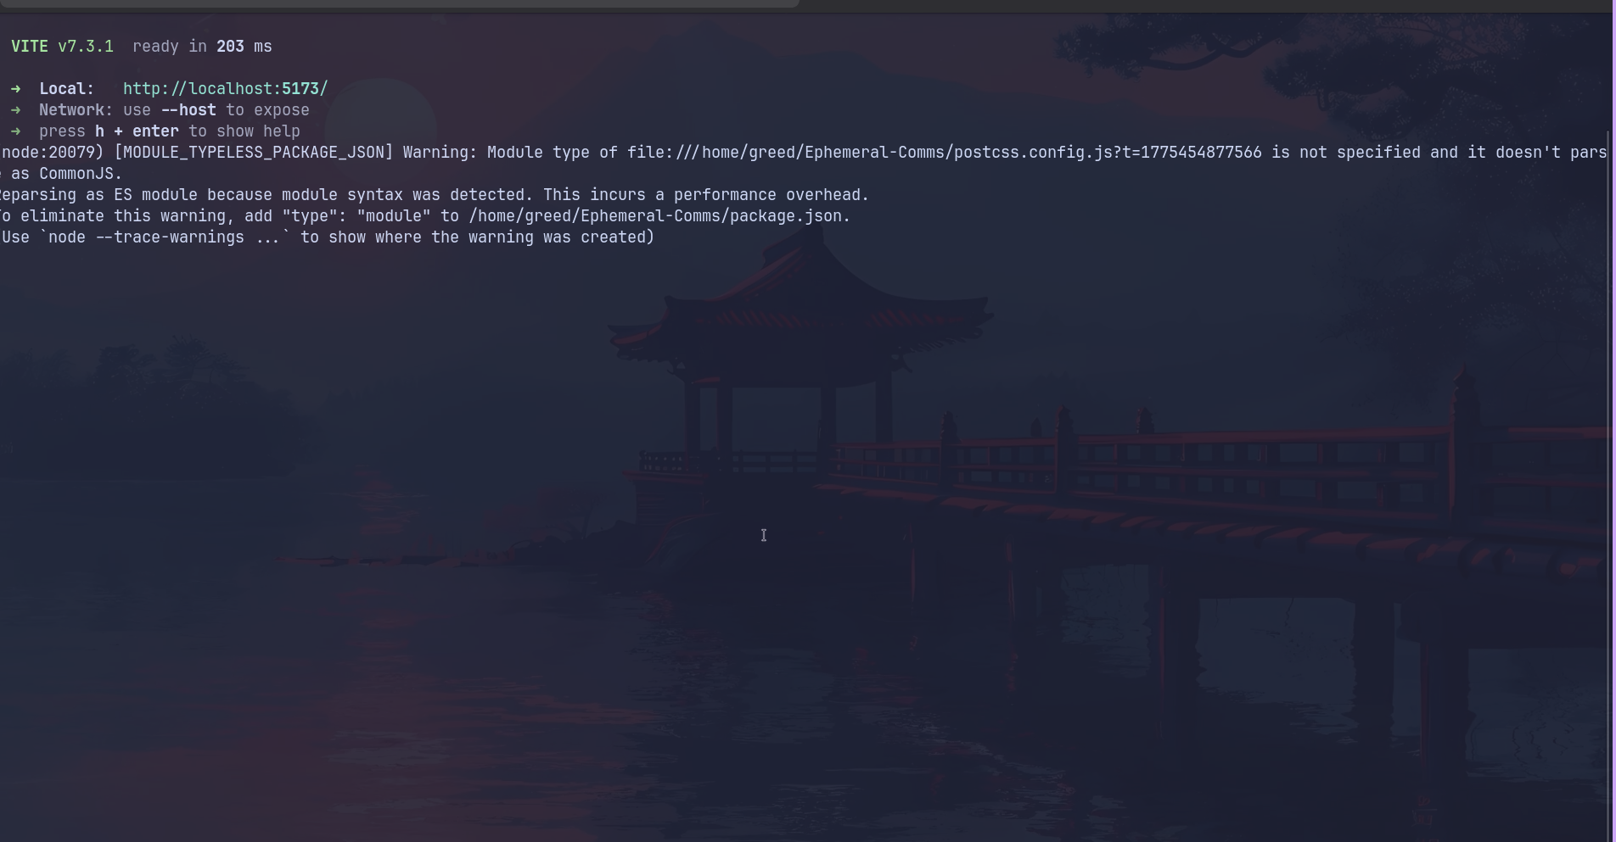
BackEnd Node-Server Execution
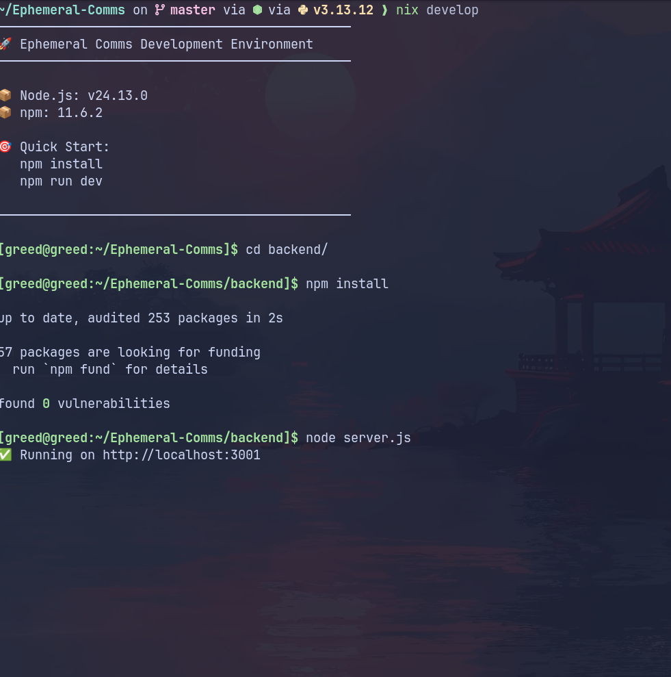
Integration and Development testing 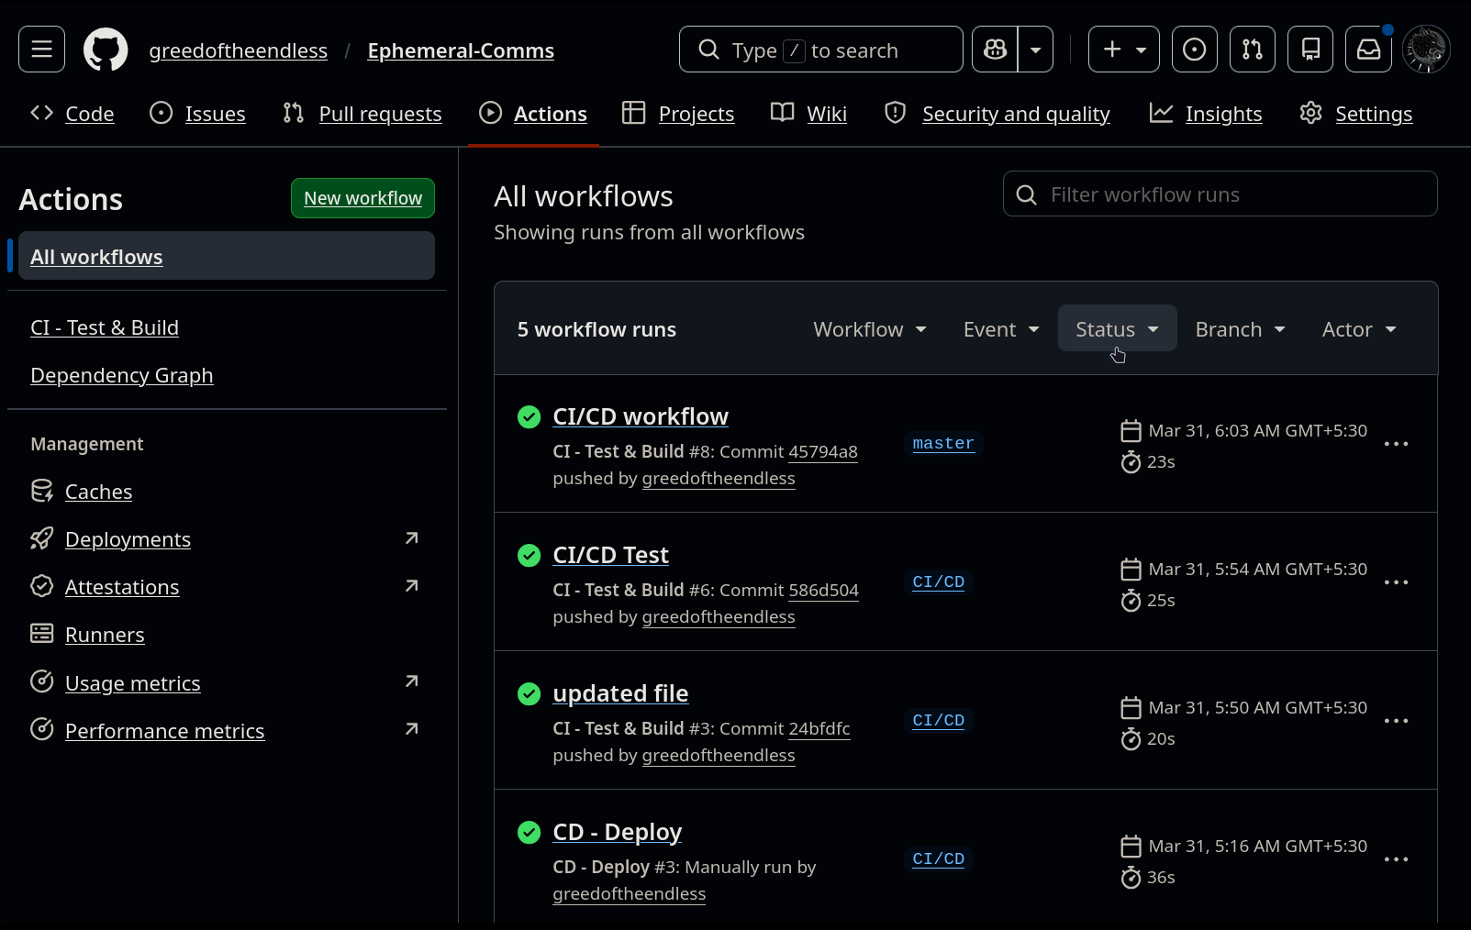
Selenium Testing(with the code)
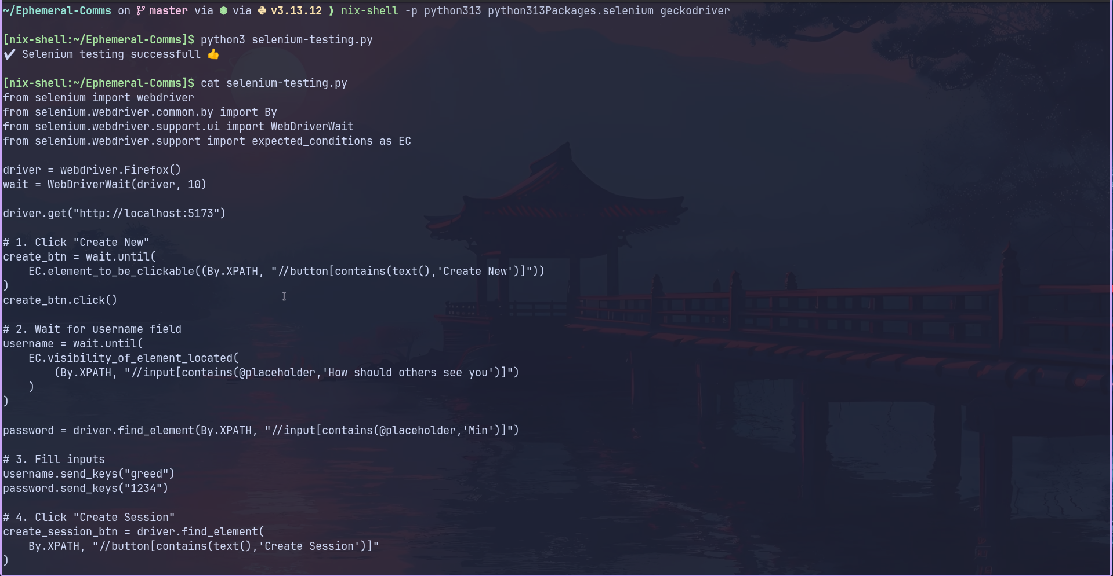

6.Project Features

Ephemeral Comms offers a suite of real-time communication tools designed for temporary, privacy-first group interaction with zero data retention.

6.1 Real-Time Messaging
Using Socket.IO, this feature enables instant bidirectional message delivery across all participants in a room. Messages are broadcast to every connected client the moment they are sent, with no polling or page refresh required — driven entirely by persistent WebSocket events.

6.2 Ephemeral Room Management
The dashboard allows users to create new chat rooms, set a room name and optional password, and share access with others dynamically. Rooms are spun up on demand and dissolved automatically when all participants disconnect or a session timeout is reached, ensuring no lingering sessions occupy server resources.

6.3 Participant Presence Indicators
The platform includes a live presence system that tracks and displays who is currently active in a room. Join and leave events are broadcast in real time to all participants, giving users full visibility of who they are communicating with at any given moment — without storing any user identity beyond the active session.

7.User Guide

This section provides comprehensive instructions for deploying and interacting with the API Performance Monitor platform.

Installation Instructions:
Step 1: Ensure Node.js (v20 or above) are installed on your local environment. Clone the project repository and install all necessary dependencies by running npm install from the root of the monorepo. This will install packages for both the frontend and backend workspaces.
Step 2: Launch the application locally by executing bash dev.sh in your terminal. This script initializes a tmux session that concurrently starts the Vite development server for the React frontend and the Node.js/Socket.IO backend server.
Step 3: Open a web browser and navigate to http://localhost:5173 to access the Ephemeral Comms chat interface, with the backend running on http://localhost:3000.

User Interface Guide:
The interface is designed for simplicity and immediacy, allowing users to enter and exit chat sessions with minimal friction through the following interactions:
Creating a Room: On the home screen, enter a desired room name and an optional password, then click "Create Room". The server instantly registers the session and redirects you into the live chat view.
Joining a Room: Enter the exact room name shared with you by the host. If the room is password-protected, you will be prompted to enter the password before gaining access. Once authenticated, you are connected via WebSocket and can begin messaging immediately.
Sending Messages: Type your message in the input field at the bottom of the chat view and press Enter or click Send. Your message is instantly broadcast to all active participants in the room via Socket.IO.
Inviting Participants: Once inside a room, use the "Invite" option to generate a shareable room link or copy the room credentials directly. Share the room name and password with intended participants through any external channel — they can join instantly by entering the credentials on the home screen.
Notifications: The platform delivers real-time in-app notifications for key session events. Participants receive alerts when a new user joins or leaves the room, when a message is received while the chat window is not in focus, and when the room is approaching dissolution due to inactivity. These notifications ensure all participants remain aware of the session state without needing to monitor the screen continuously.
Leaving a Room: Close the browser tab or navigate away to disconnect. If you are the last participant to leave, the room is automatically dissolved and all messages are permanently purged from the server.

Leaving a Room: Close the browser tab or navigate away to disconnect. If you are the last participant to leave, the room is automatically dissolved and all messages are permanently purged from the server.

8.Conclusion & Future Scope

This section summarizes the project's outcomes and identifies potential areas for further enhancement.

8.1 Conclusion
Ephemeral Comms successfully demonstrates a functional and scalable solution for real-time, privacy-first group communication. By integrating a Node.js/Socket.IO backend with a React/Vite frontend deployed across Vercel and Render, the system achieves near-instantaneous message delivery through persistent WebSocket connections. The project meets all core objectives, including ephemeral room lifecycle management, real-time participant presence tracking, in-app notifications, and a zero-persistence architecture that guarantees all session data is permanently discarded upon room dissolution. Ephemeral Comms provides a lightweight yet effective alternative to conventional messaging platforms for users who prioritize transience and privacy over long-term data retention.

8.2 Future Scope
While the current version of the platform is fully operational, several enhancements are planned for future iterations:
User Authentication: Implementing an optional account system to allow users to maintain persistent display names and profile pictures across sessions, without compromising the ephemeral nature of the messages themselves.
End-to-End Encryption: Integrating client-side encryption so that message content is encrypted before transmission and decrypted only on the recipient's device, ensuring that even the server has no visibility into message payloads.
Room Scheduling & Timed Expiry: Adding the ability for room creators to define a fixed session duration at the time of creation, after which the room automatically dissolves regardless of participant activity — useful for structured, time-boxed discussions.
Mobile Application: Developing native iOS and Android clients to extend Ephemeral Comms beyond the browser, enabling push notifications and a more seamless mobile communication experience.

9.References

1. Brown, E. (2019). Web Development with Node.js and Express: Leveraging the JavaScript Stack. O'Reilly Media. (Used for backend server architecture and Express.js routing design).
2. Socket.IO Documentation. (2026). Bidirectional and Low-Latency Communication for Every Platform. Available at: https://socket.io/docs/. (Used for the core real-time WebSocket communication engine).
3. React Documentation. (2026). The Library for Web and Native User Interfaces. Available at: https://react.dev/. (Used for building the component-based frontend chat interface).
4. Vite Documentation. (2026). Next Generation Frontend Tooling. Available at: https://vitejs.dev/. (Used for frontend development server setup and production build optimization).
5. pnpm Documentation. (2026). Fast, Disk Space Efficient Package Manager. Available at: https://pnpm.io/. (Used for monorepo dependency management across frontend and backend workspaces).
6. Vercel Documentation. (2026). Develop, Preview, Ship. Available at: https://vercel.com/docs/. (Used for frontend deployment, CI/CD pipeline configuration, and Vercel Analytics integration).
7. Render Documentation. (2026). Cloud Application Hosting for Developers. Available at: https://render.com/docs/. (Used for backend Node.js service deployment and environment management).

